1. Create S3 Bucket

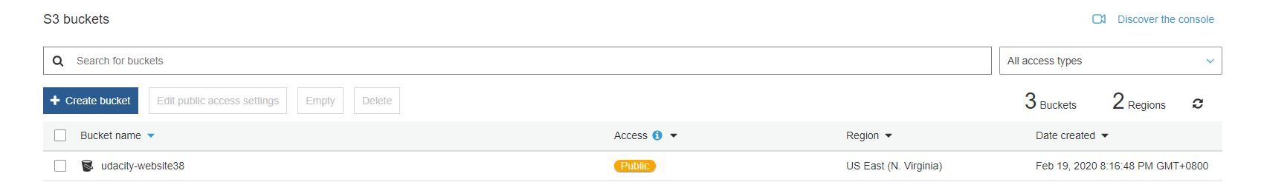

1. Upload files to S3 Bucket

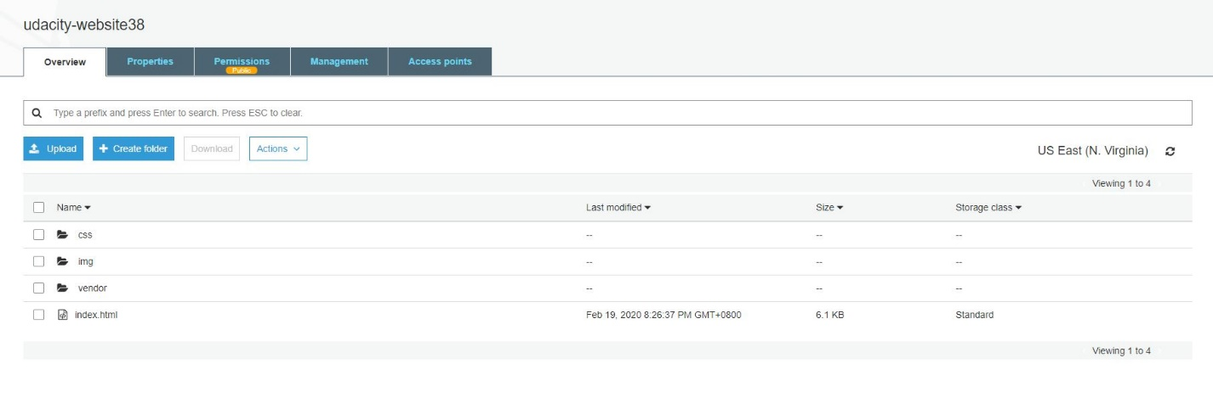

1. Secure bucket via IAM

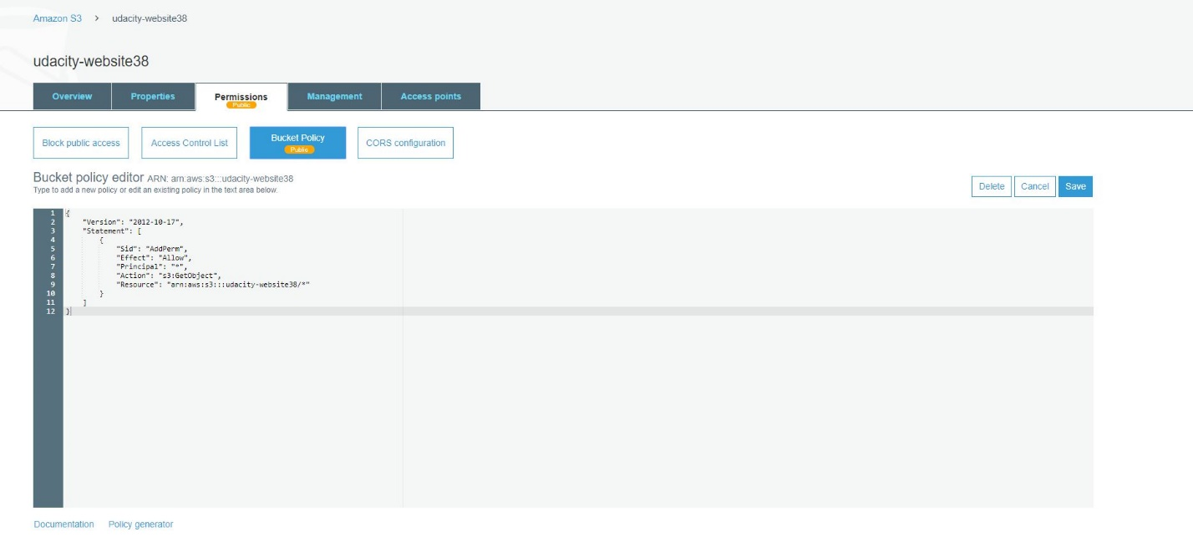

1. Configure S3 Bucket to support static website hosting

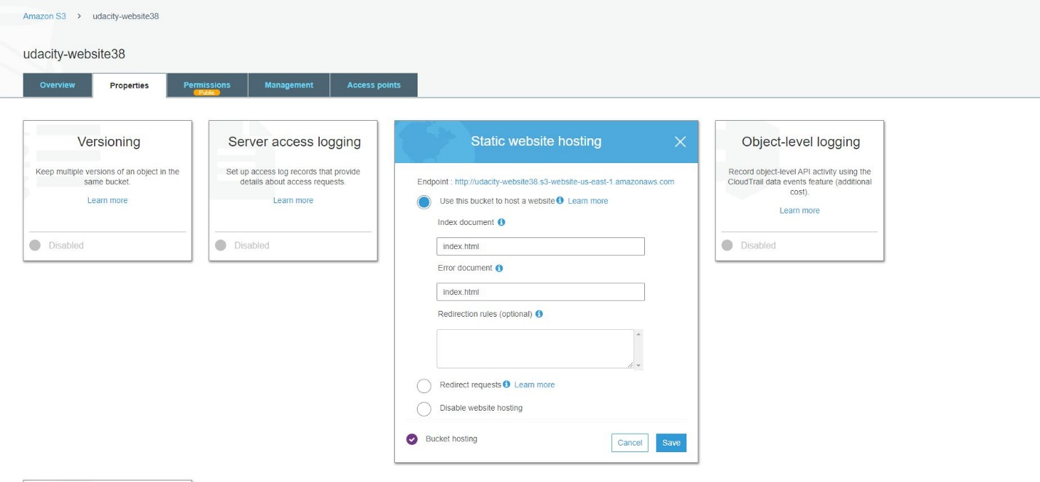

1. Distribute Website via CloudFront

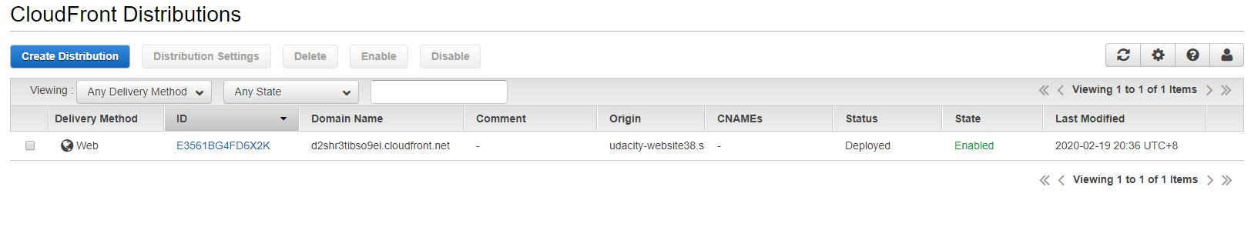

1. Access Website in Web Browser



<http://d2shr3tibso9ei.cloudfront.net/index.html>